***i*** ROBO

* *Patient’s Personal Assistant*

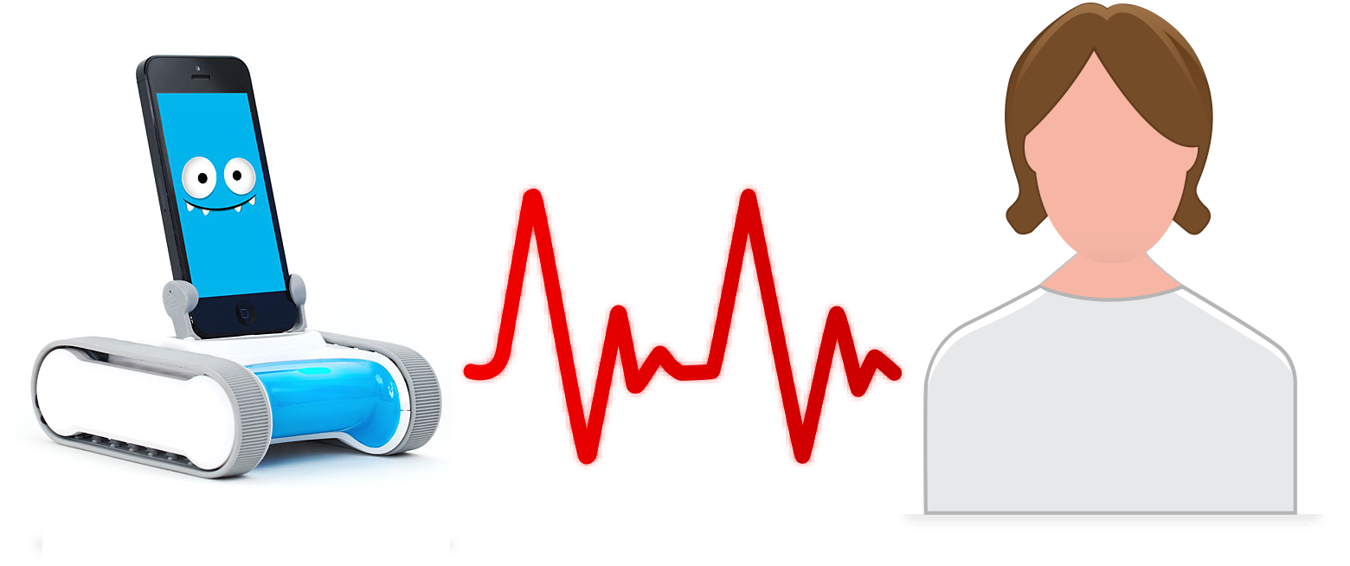

By Team #3:

Venkata Vamsi Krishna Bhuvanam (Class ID: 3)

Sowmya Yelmati (Class ID: 32)

Varun Chavakula (Class ID: 4)

Vikas Kondapalli (Class ID: 11)

Contents

1. PROPOSAL 4

1.1. Motivation: 4

1.2. Significance/Uniqueness: 4

1.3. Objectives: 4

1.4. System Features: 4

1.5. Related Work: 4

2. Project Plan 5

2.1. Features Designed & Implemented: 5

2.2. Project Timelines, Members, Task Responsibility 6

2.2.1. Timelines: 6

2.2.2. Members: 6

2.2.3. Task Responsibility: 6

3. First Increment Report 7

3.1. Existing API: 7

3.2. Design of Features: 7

3.2.1. Hadoop/Machine Learning Algorithms: 7

3.2.2. Class Diagram: 7

3.2.3. Sequence Diagram: 9

3.2.4. Sequence Diagram for emotion analysis through patient speech: 10

3.2.5. Sequence diagram for detecting environmental factors: 11

3.3. Implementation: 12

3.3.1. Face Detection: 12

3.3.2. Light Sensor and Heart Beat & Proximity Sensor: 15

3.4. Deployment: 17

4. Second Increment Implementation: 18

5. Second Increment Screenshots: 19

6. Third Increment Implementation: 22

7. Third Increment Screenshots: 29

8. Third Increment Implementation: 36

9. Third Increment Screenshots: 37

10. Bibliography: 47

11. Presentation Slides: 48

12. Github URL: 52

13. Youtube URL: 52

14. Project Summary Report: 52

14.1. Introduction: 52

14.2. Solutions: 53

14.2.1. Architecture: 53

14.2.2. Algorithms: 53

14.2.3. Data: 56

14.2.4. Accuracy: 56

14.2.5. Runtime Performance: 57

15. Project Management Report: 58

15.1. Project Management Report 58

15.1.1. Members Work Evaluation: 58

15.2. Final Project Evaluation: 58

# **PROPOSAL**

## Motivation:

In medical field in any hospital patients feel so lonely after some days and even research proved that constant attention helps healing faster than keeping them lonely. So this robot will interact with patients based on their mood swing. This will even help doctors to keep on monitoring patient under doctor’s radar.

## Significance/Uniqueness:

Say that patient is happy, it will ask in cheering voice that “ How are you sir, Seems like you are so happy, is it because of any happy memories, or any good news, can you please share with me too…” or if patient is so sad, based on his medical history it will talk saying that “ You seem so sad sir, don’t feel that way, be happy, Can I sing some songs, can I dance <to make it laugh>, can I tell joke”

## Objectives:

This will help patient think in good mood and won’t make them feel lonely. Also in hospital room it will keep on monitoring the monitors and will keep on updating doctors on the status of the patient by using patient id and name using messaging/email. Robot might even suggest calling particular people based on mood swings. This robot might even translate from one language to another where patient will talk in one language and it talks back to doctor in another language.

## System Features:

Features May Include:

* + - Constant Relay of Front Cam video to Source Phone
    - Movement by speech
    - Image Recognition/Mood Recognition
    - Object Recognition
    - Patient Records search
    - Language Translation

This Robot will also assist the people who can’t speak/hear by identifying sign language and showing in form of text on screen on what it want to say.

Furthermore scope can be expanded based on the user’s work/needs.

## Related Work:

Till now some specialized hospitals have robots which will just assist doctors while attending patients and nowhere personalized robots are manufactured/coded.

# **Project Plan**

## Features Designed & Implemented:

* Identifying the emotion analysis in video, but currently we are able to identify the face in an image, this video analysis is scheduled for next increment. (faceplusplus API, kairos API).
* Proximity to detect the objects.
* Light sensor used to detect the atmosphere lightings.
* Getting the Heartbeat as notification to Smartwatch based on the critical changes to heart beat.

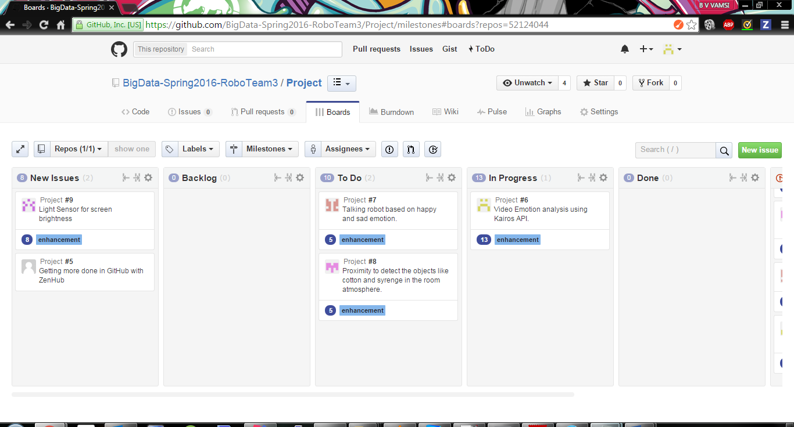

## Project Timelines, Members, Task Responsibility

### Timelines:

|  |  |
| --- | --- |
| Date | Increment # |
| 2/19/2016 | **Plan & Project Increment 1** |
| 3/11/2016 | **Project Increment 2** |
| 4/6/2016 | **Project Increment 3** |
| 4/29/2016 | **Project Increment 4** |

### Members:

1. VENKATA VAMSI KRISHNA BHUVANAM
2. SOWMYA YELMATI
3. VARUN CHAVAKULA
4. VIKAS KONDAPALLI

### Task Responsibility:

1. SPARK Machine Learning Tasks: Vikas Kondapalli
2. API and Emotion analysis: Venkata Vamsi Krishna Bhuvanam
3. ROBO Movements & Speech : Sowmya Yelmati
4. Speech emotion Analysis: Varun Chavakula

# **First Increment Report**

## Existing API:

* We will be using Kairos Emotion Analysis API for analyzing the patient’s face in the video and based on the emotion, particular action will be taken.
* Also we will be using Speech to Text API so that the robo will interact with patient based on the training set provided to it.

## Design of Features:

### Hadoop/Machine Learning Algorithms:

#### Supervised Learning:

For Supervised Learning we are planning to use K- Nearest Neighbors or Decision Tree Machine Learning Algorithm.

Steps in Supervised Learning:

• Prepare Data

• Choose an Algorithm

• Fit a Model

• Choose a Validation Method

• Examine Fit and Update Until Satisfied

• Use Fitted Model for Predictions

#### Un-Supervised Learning:

* For un-supervised Learning we are planning to use K- Means Clustering Algorithm.

### Class Diagram:

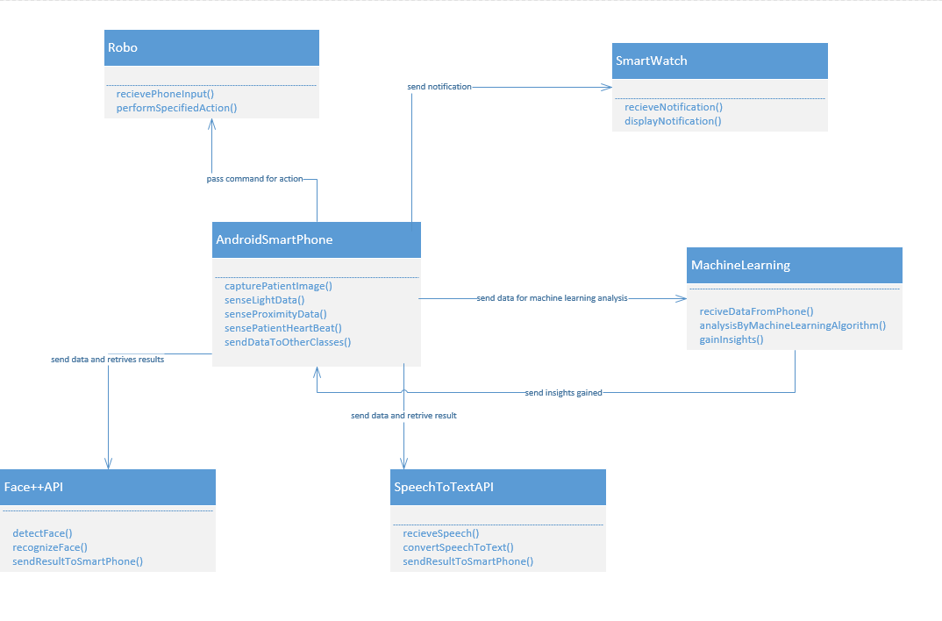

This class diagram is only up to the design and features which have been planned till now, this design may modify and get completed in future increments.

#### Explanation:

The classes in this design are

* Robo: This class represents the actual Robo which is used in the project. This class receives the command from smartphone and performs the specified action. The actions include movement action, talking action etc.
* Smartwatch: This class represents the actual android smartwear which is used in the project. This class receives the notification from the smart phone and displays the corresponding notification.
* Face++ API: This class represents the open source Face++ API. It receives the image data from the smartphone and detects, recognizes the faces present in the image.
* SpeechToTextAPI: This class represents the open source Speech to text API which is used in this project. This class receives the audio data from smart phone and converts the speech in it to text.
* MachineLearning: This class represents the Machine Learning module in this project. This class receives data from smart phone and machine learning analysis on the data in Spark using Spark machine learning library to recognize the patterns and gain meaningful insights.
* AndroidSmartPhone: This is the center class of the design which represents the android phone used in the project. This class collects the data from different sources. It send the data like image and speech to Face++ and SpeechToText APIs respectively. It then sends this data to machine Learning module for analysis. It then receives results from machine learning module and sends notifications to smartwatch and commands to Robo based upon the context.

### Sequence Diagram:

Sequence diagram for emotion analysis through patient face:

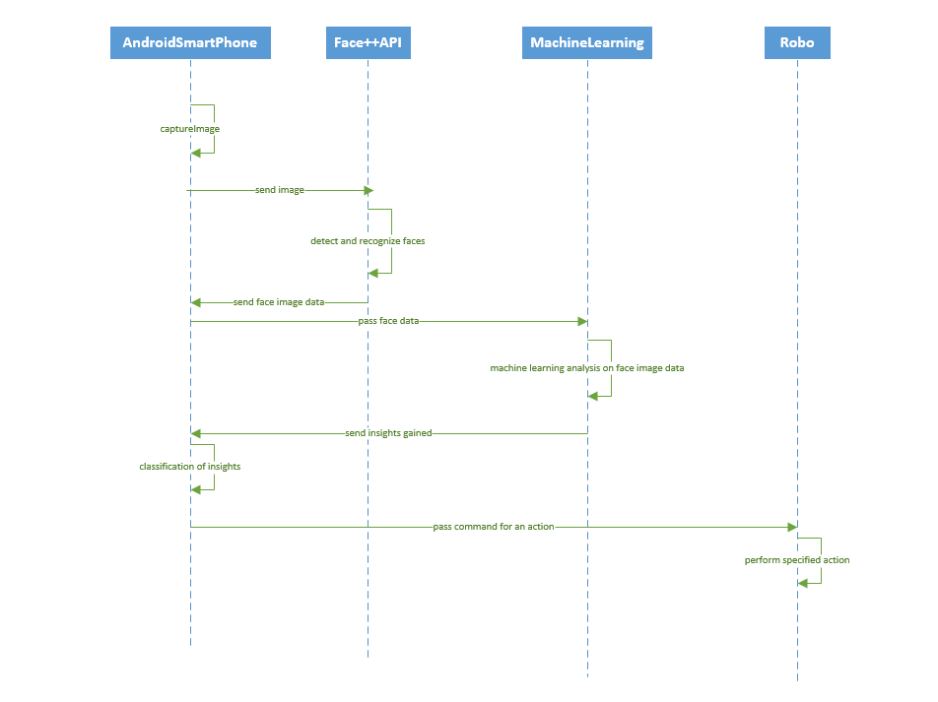

* In this Sequence Diagram, Android smartphone captures patient images and sends that data to Face++ API.
* Face++ API then processes that image and detects the face part of the image and sends that data to mobile client.
* The mobile client sends this data to machine learning module in data is analyzed to gain useful insights and pass that data to mobile client. This insights are classified and corresponding commands are passed to Robo.

### Sequence Diagram for emotion analysis through patient speech:

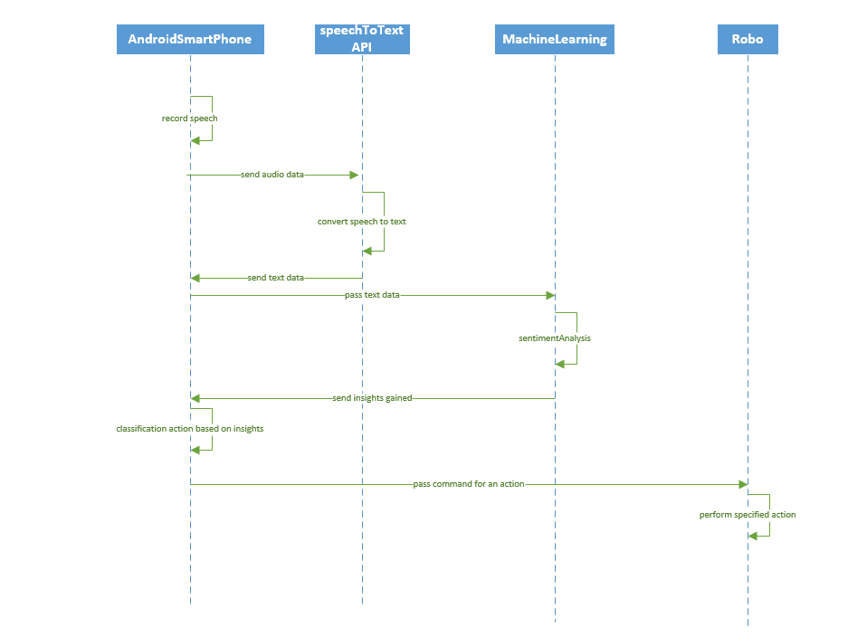

* In this Sequence Diagram, Android smartphone records patient speech and sends that data to Speech to Text API.
* Speech To Text API then processes that audio data and converts it into text.
* The mobile client sends this data to machine learning module in data is analyzed to gain useful insights and pass that data to mobile client. This insights are classified and corresponding commands are passed to Robo.

### Sequence diagram for detecting environmental factors:

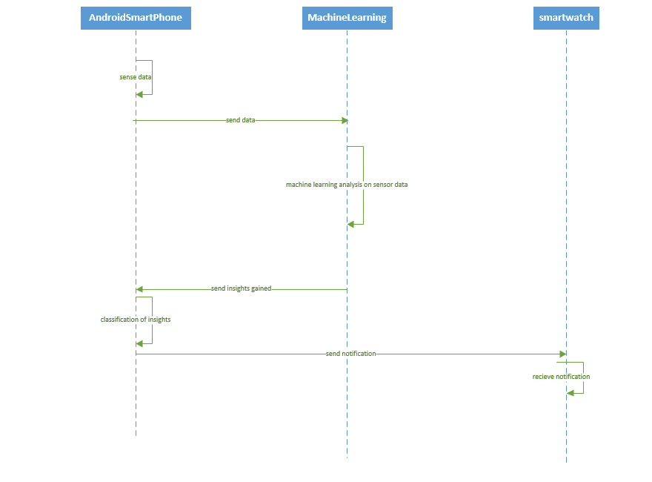

* In this Sequence Diagram, Android smartphone senses the environmental data such as Lighting, any nearby objects and patient heartbeat.
* The mobile client sends this data to machine learning module in data is analyzed to gain useful insights and pass that data to mobile client. This insights are classified and corresponding notifications are passed to Smart watch.

## Implementation:

### Face Detection:

* First select the image from the gallery

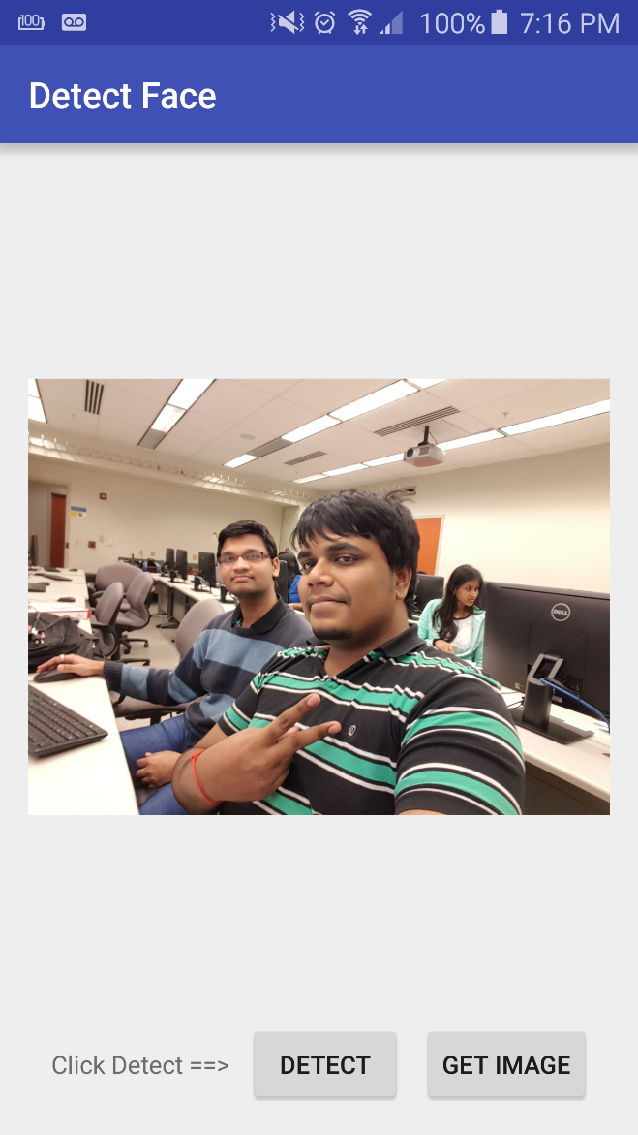

* Click on Detect Button (which will be triggered automatically on the camera active method)

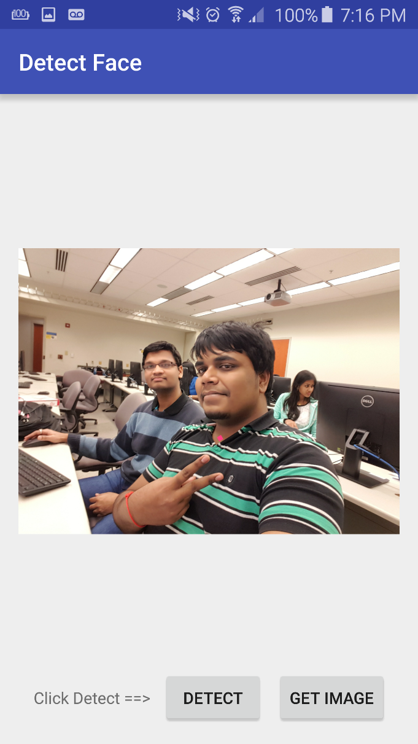

* Total faces in the image will be detected and highlighted. (In the same way using Kairos api we will detect the emotion in a video)

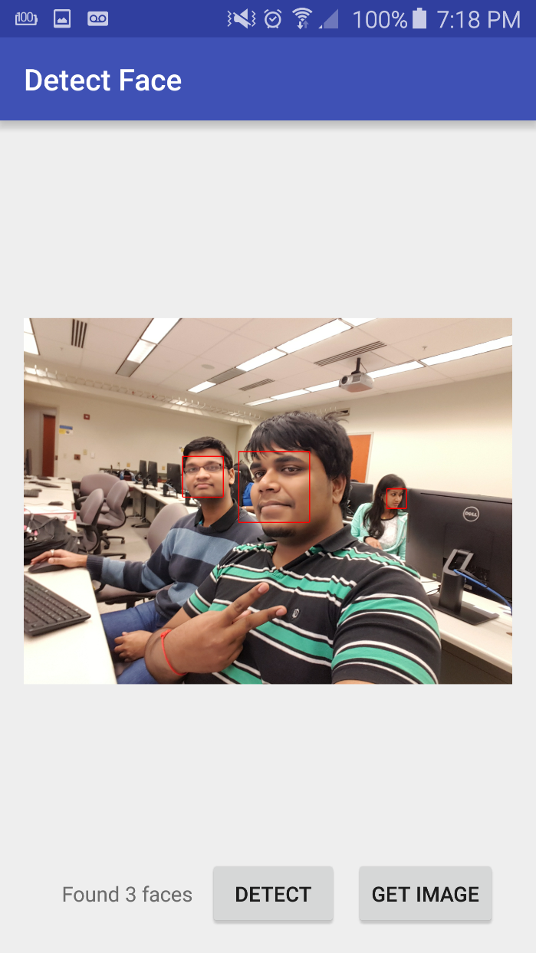

### Light Sensor and Heart Beat & Proximity Sensor:

* Light and Proximity Sensors will be sensed and the proper action will be performed by robo.

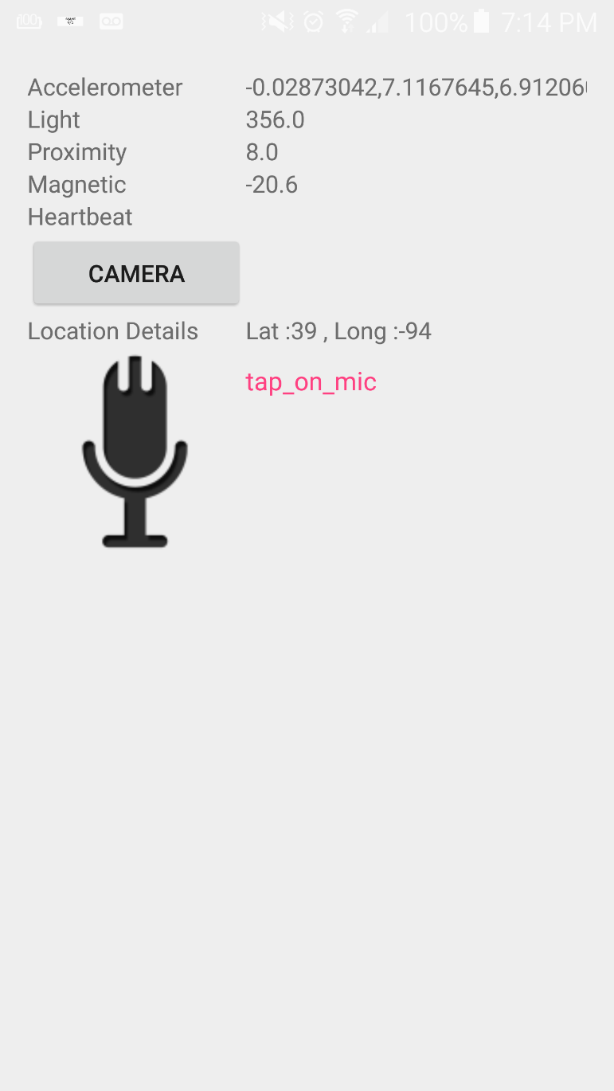

* Heart-beat of the patient will be recorded and the prompt action like sending alert to doctors if fallen/risen of heart beat to critical stage.

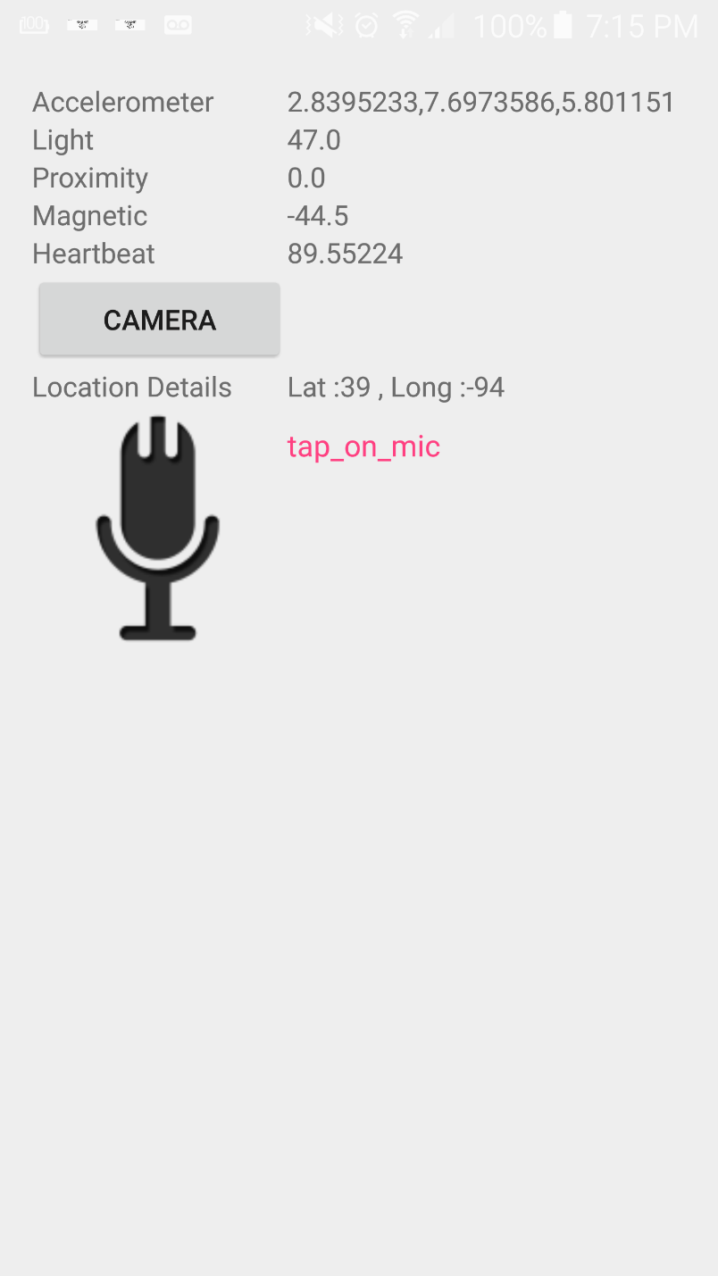

## Deployment:

Github for Face Plus Plus: <https://github.com/BigDataSP2016TutorialLab/Lab-1/tree/master/Lab-4/Source>

Github for Light Sensor and Proximity Sensor: <https://github.com/Vikas-kondapalli/Lab_Assignments/tree/master/source/Assignment3_sourcecode/Lab3>

# Second Increment Implementation:

* 1. Mobile Phone to Spark Connection:

Here we have created an android application which will send the data stream to spark by creating a socket stream connection. We have implemented speech to Text implementation and sending that text to Spark Server.

* 1. Sending data to Spark:

Here the data is sent to Spark server by creating a socket streaming connection with spark and sending data over to Spark.

* 1. Sentiment Analysis on Spark:

Here once the data was sent to Spark server, that data will be analyzed using Stanford NLP and predicted whether the sent data is positive or negative scenario related.

* 1. Getting Response back to Phone from Spark:

Based on the information analyzed by Stanford NLP the analyzed data will be sent back to phone where the android phone will do further analysis on that and will perform particular set of operations based on output. For example if output is positive, then robot/android phone will ask “You seem to be in happy/nice mood. How are you doing today?” If the output is negative, then the robot/android phone will ask “You seem so sad/feeling down today. Feel better soon. Can I play a song for you or tell a joke”

# Second Increment Screenshots:

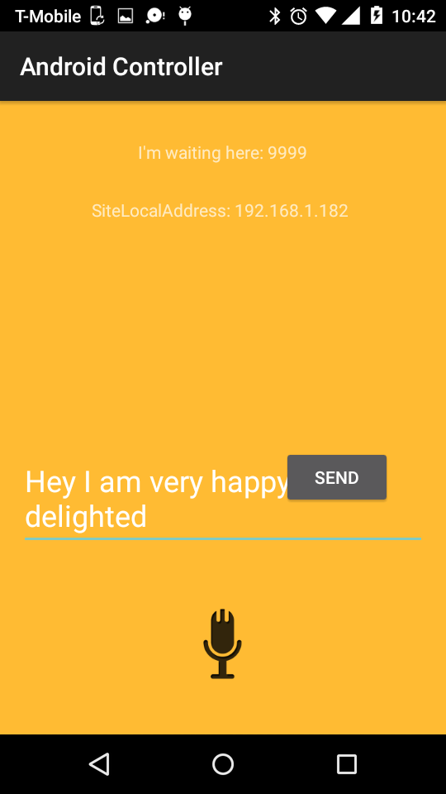

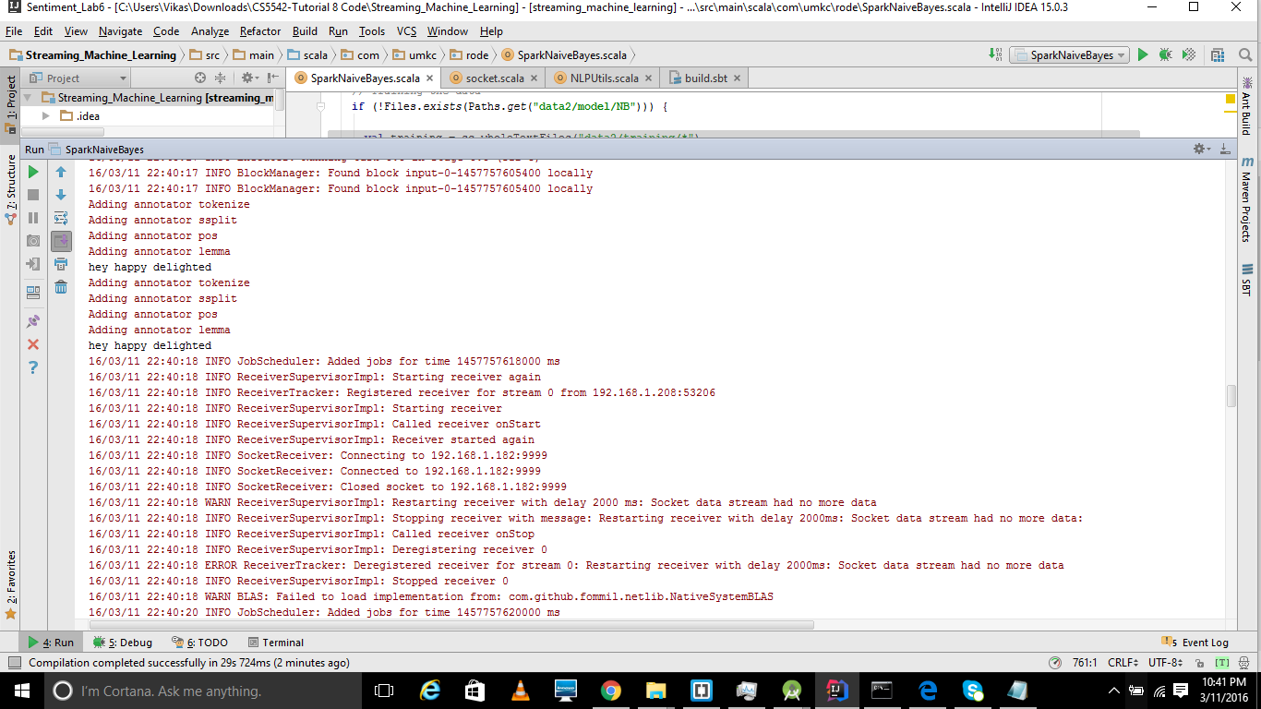

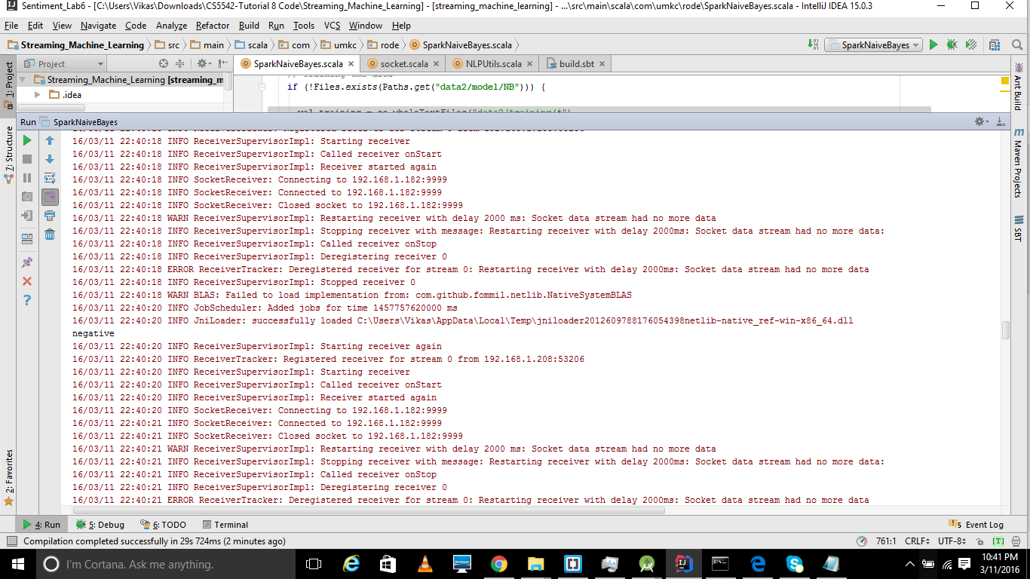

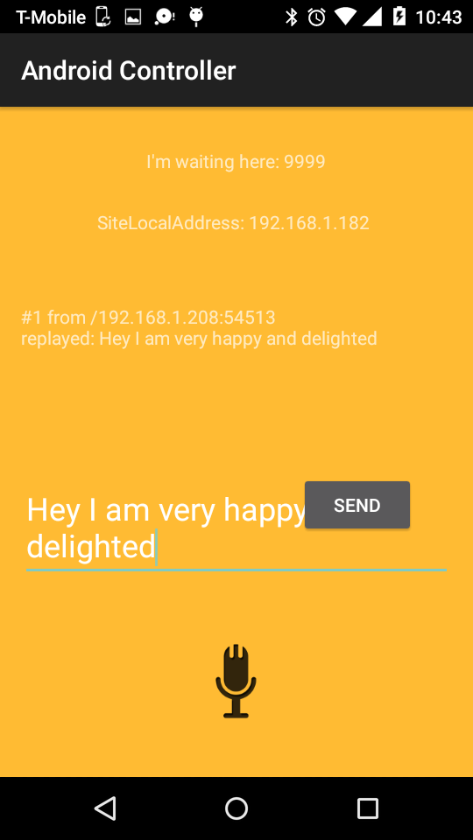

# Third Increment Implementation:

1. First we have done with image classification for checking whether the patient is laughing/sad/angry. Here we have taken some sample images of people who are laughing and sad and angry, then we are classifying the faces and we are sending the image from phone as input to verify which category that image was classified into. Based on that classification we will get an output that whether the person is angry/sad/happy.
2. Second we have done with music recommendation, where we will recommend the type of music based on the patient condition. If the patient is happy then the system will recommend with pop/rock genre music, if patient id sad then the system will recommend with blues/other genres which will make the person feel better.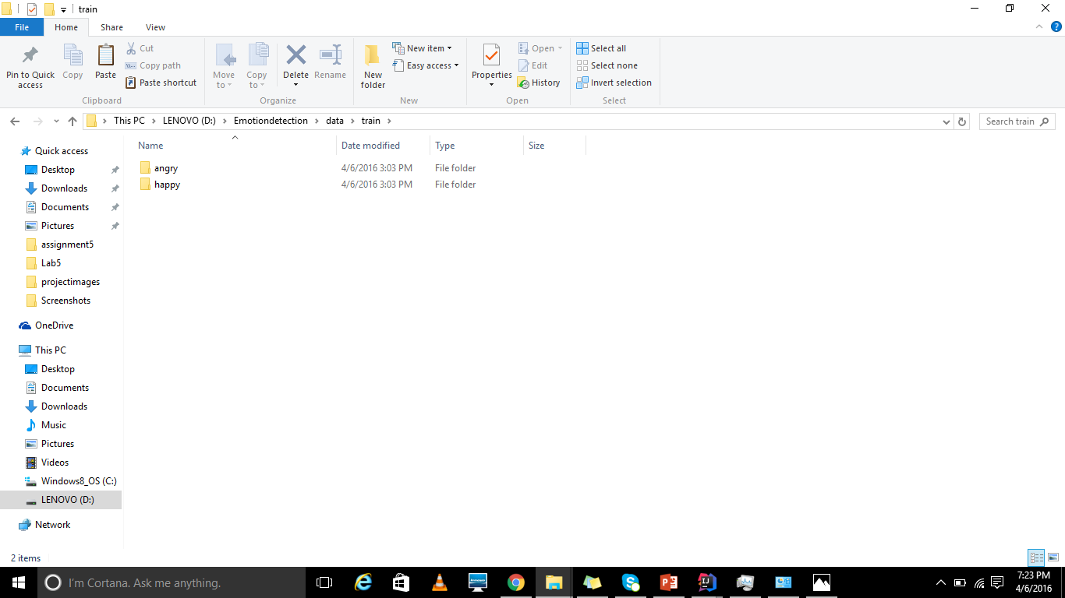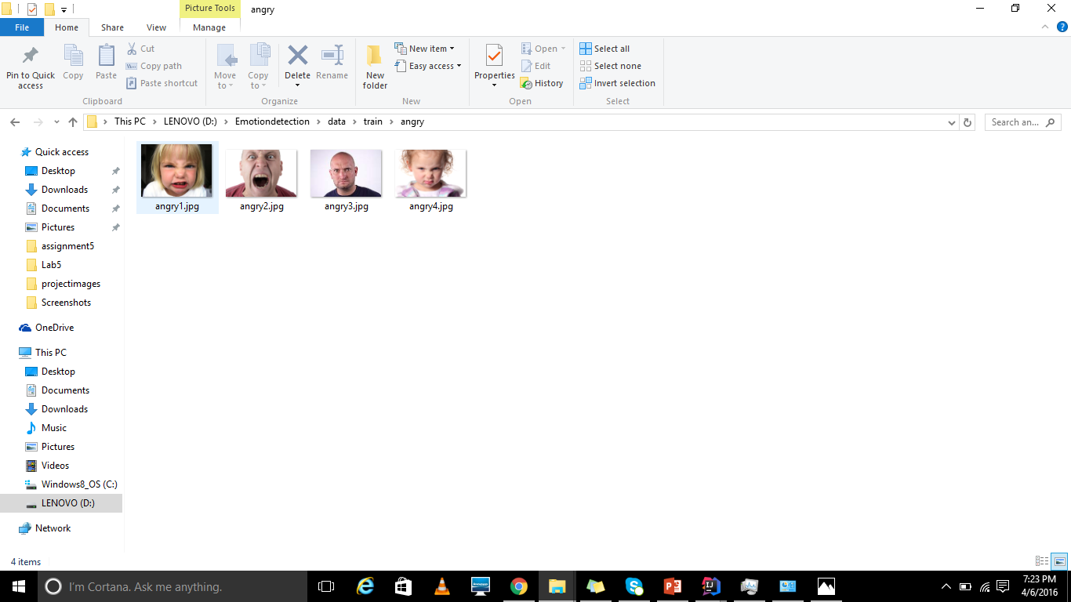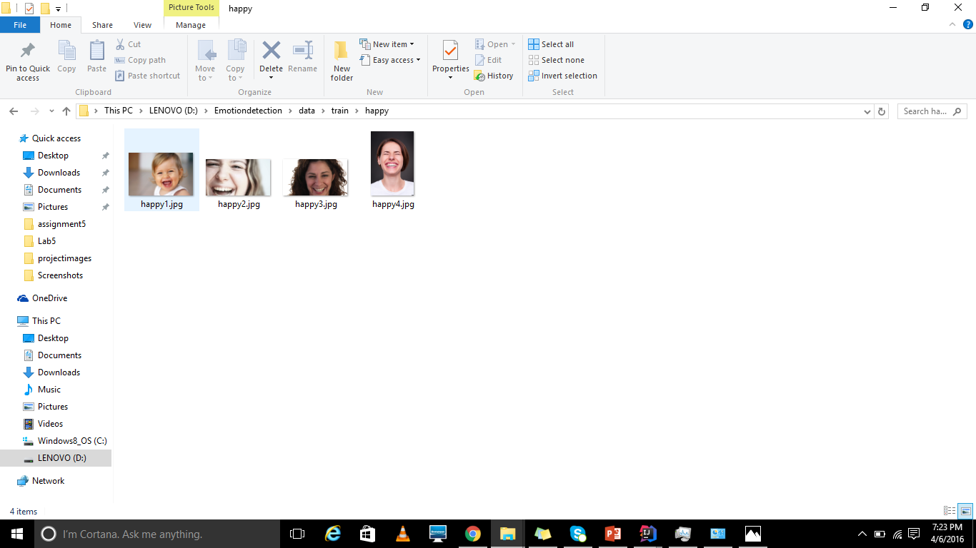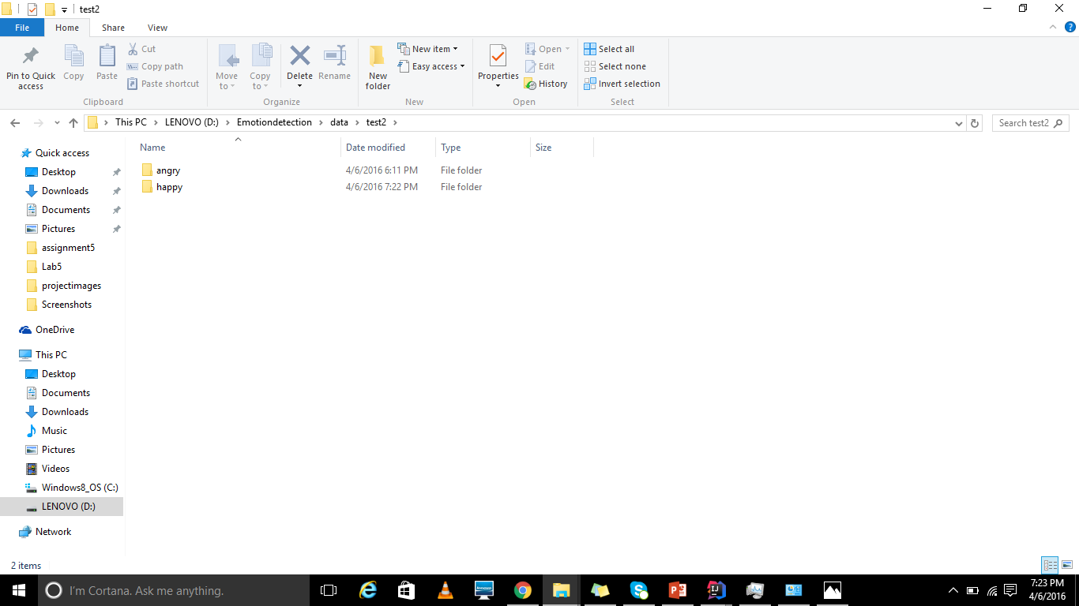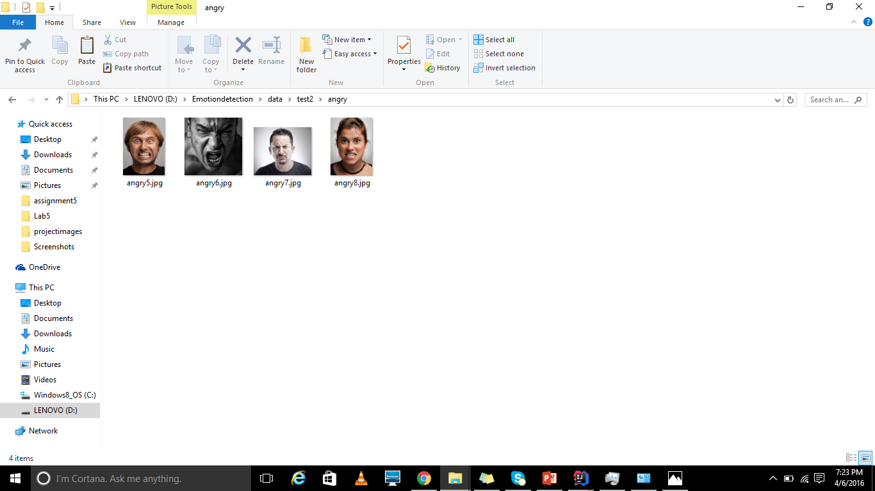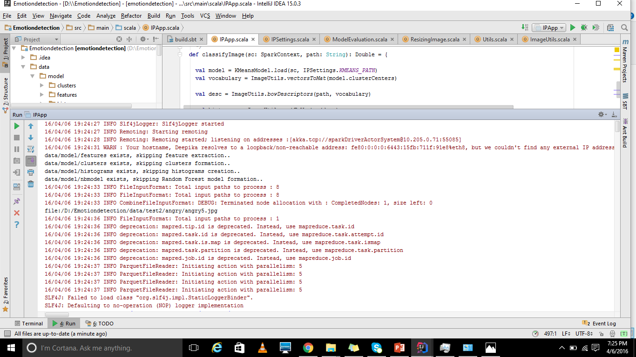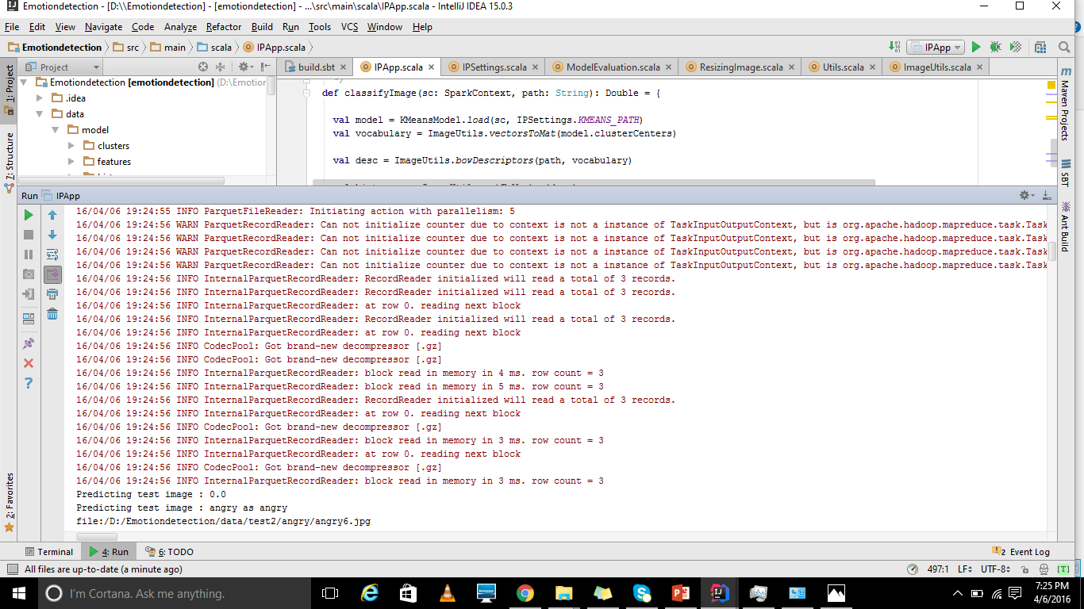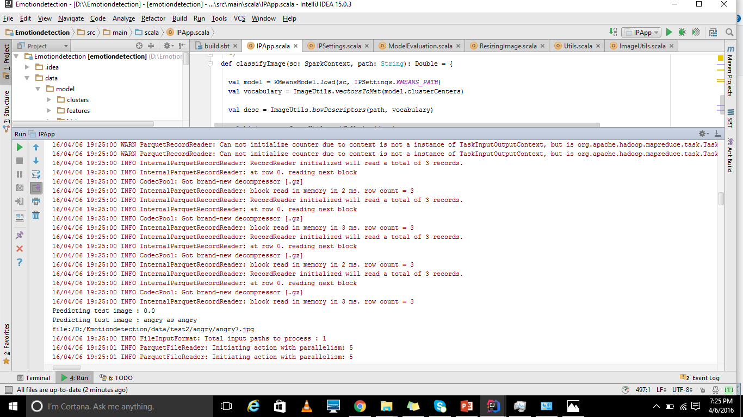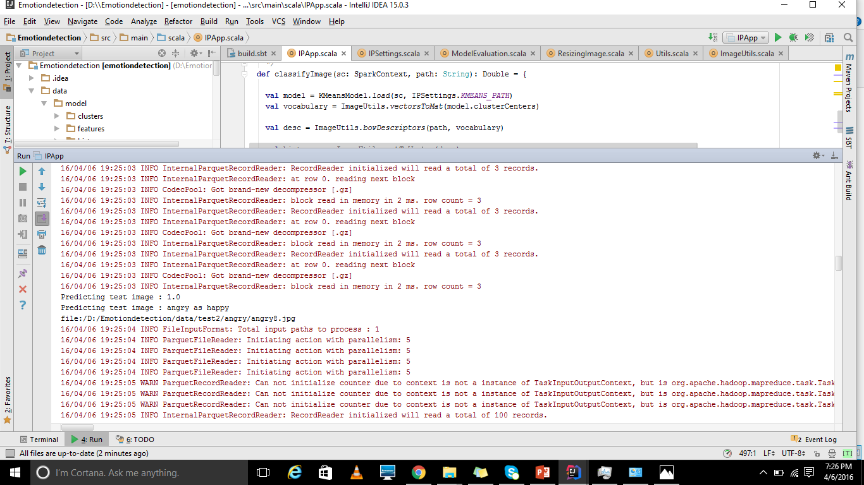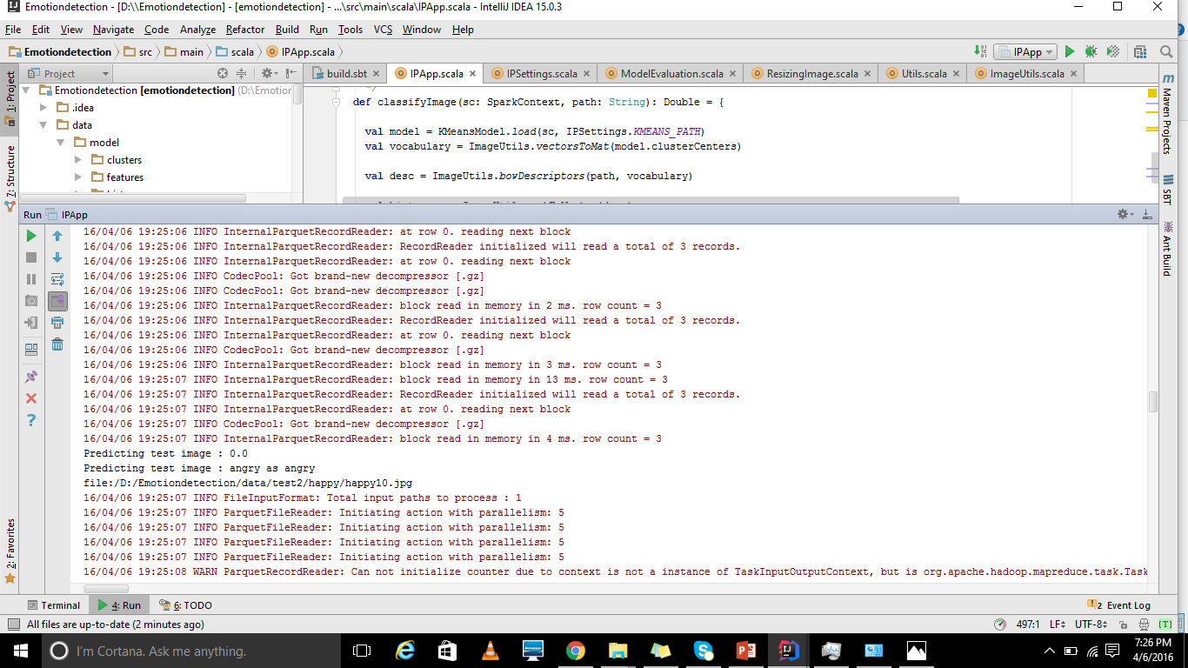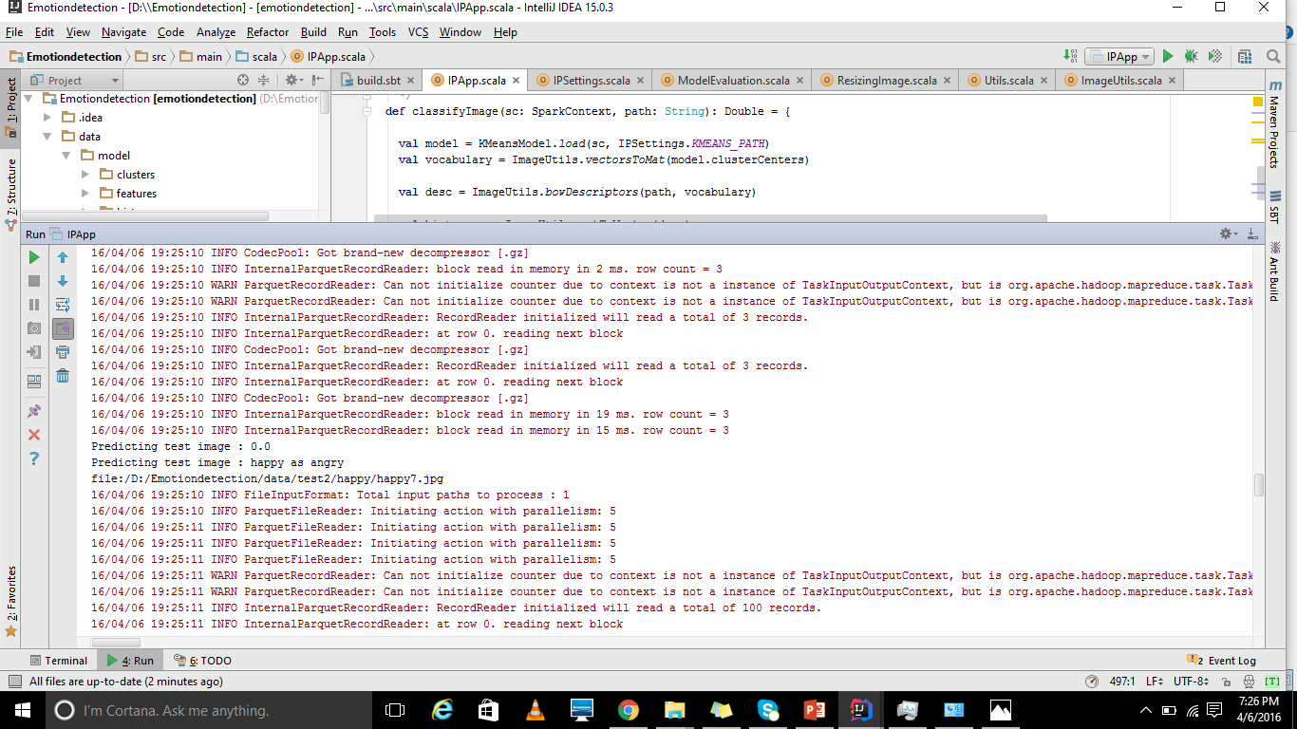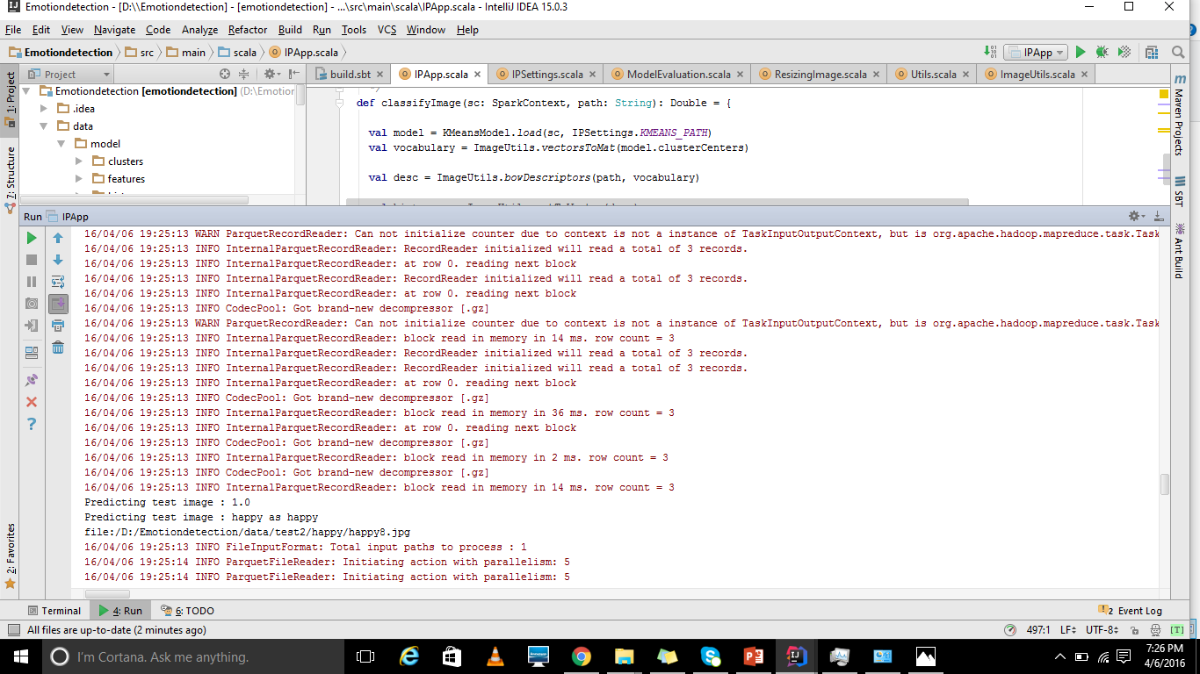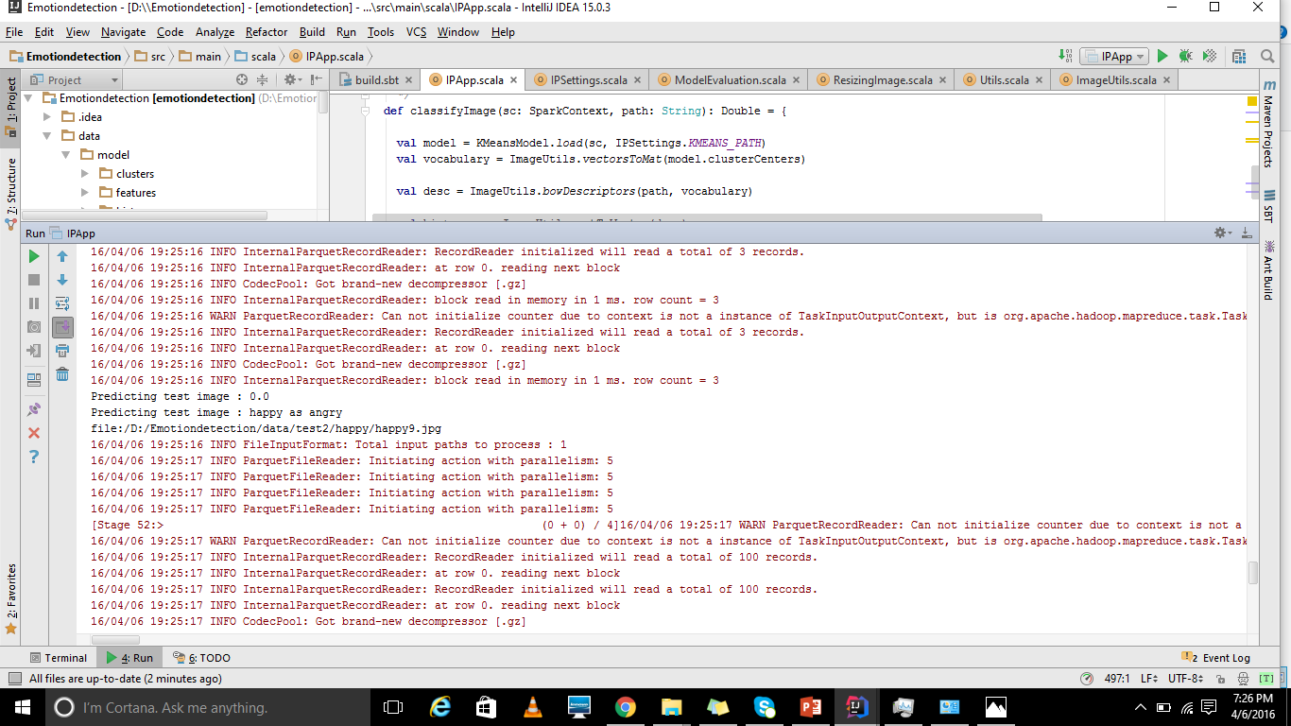

# Third Increment Screenshots:

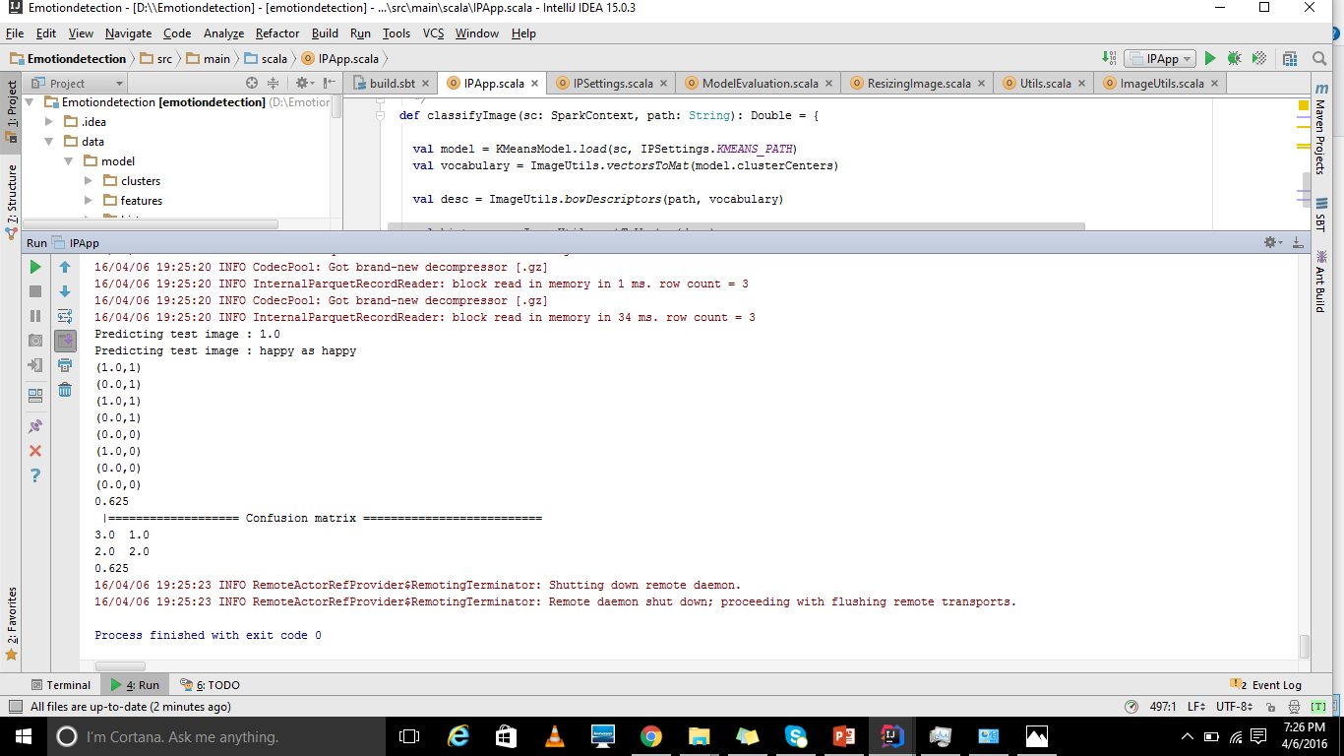

# Fourth Increment Implementation:

1. First we have completed the streaming of the files from android to machine/spark where the image classification will be done after receiving every image. Based on the image classification of the file which was sent from android, the spark will finalize the emotion of the image.
2. Second we have done with music recommendation, where we will recommend the type of music based on the patient condition. To extend to this we are saving a sample set of songs to folders and the spark machine will play the particular genre song based by taking file from folder.

# Fourth Increment Screenshots:

# 

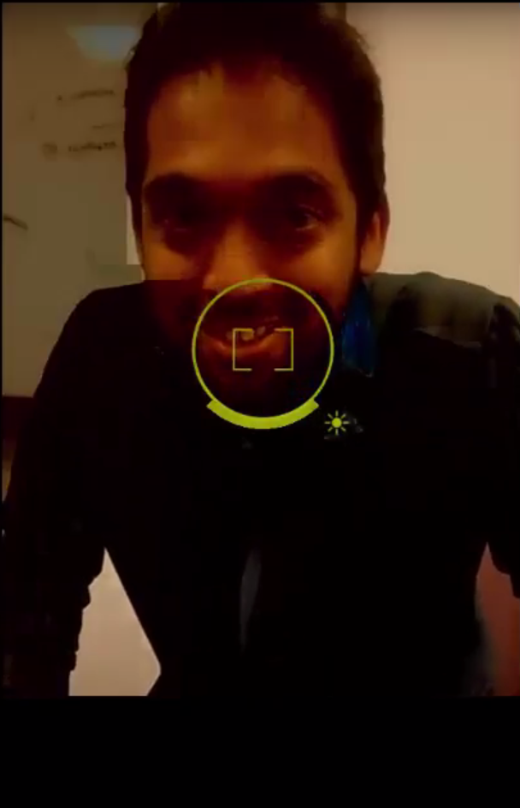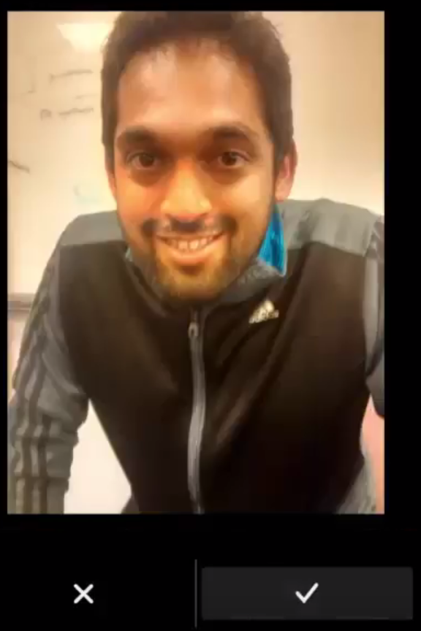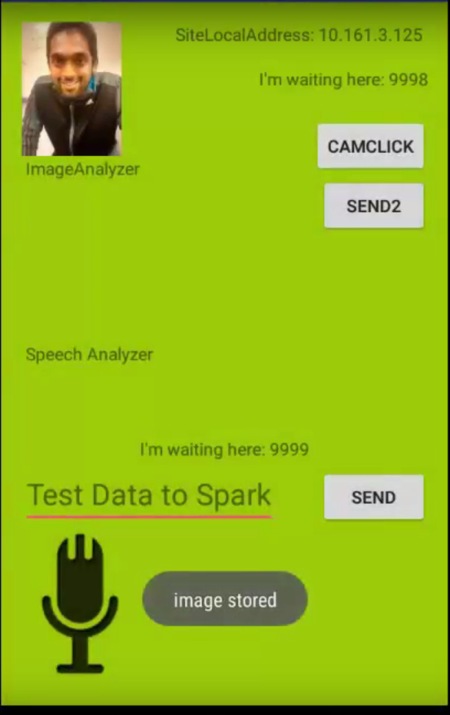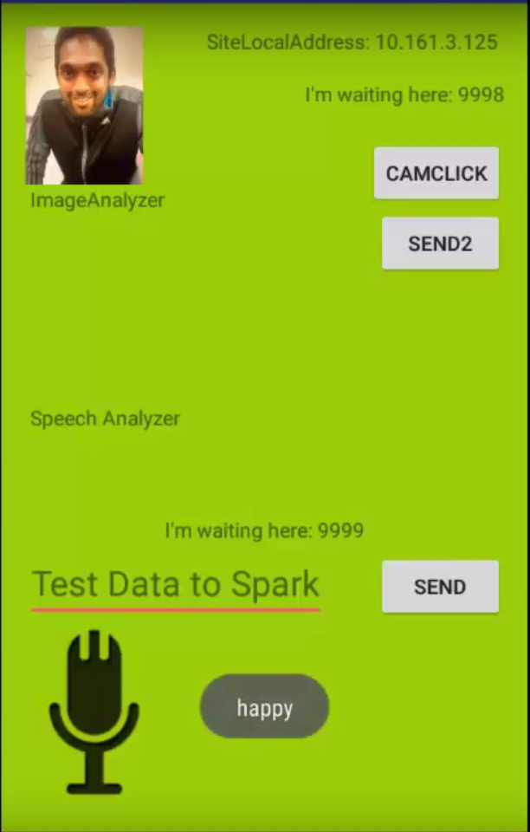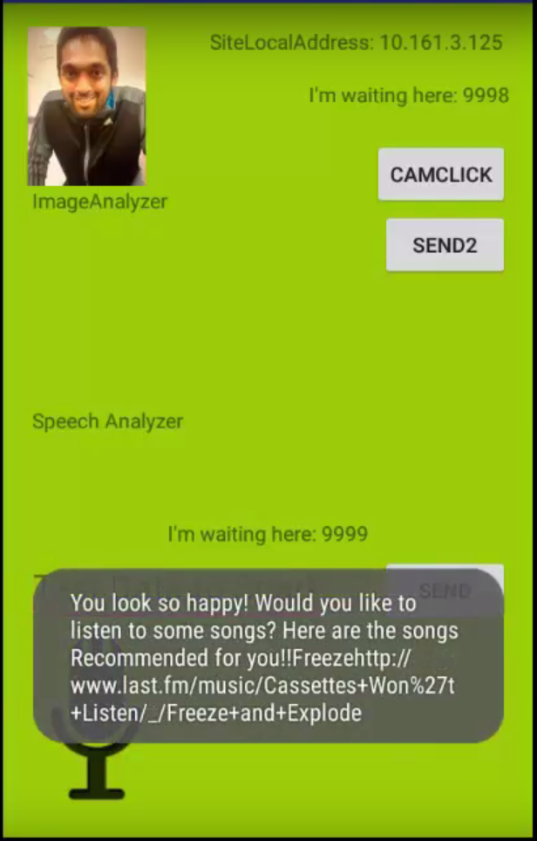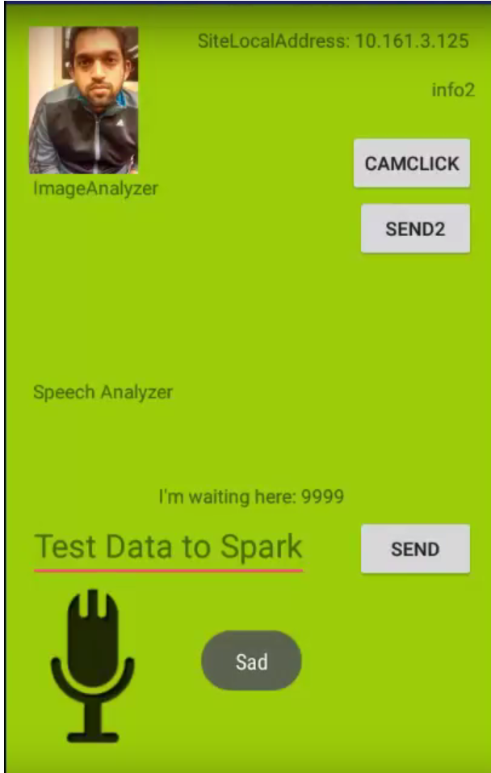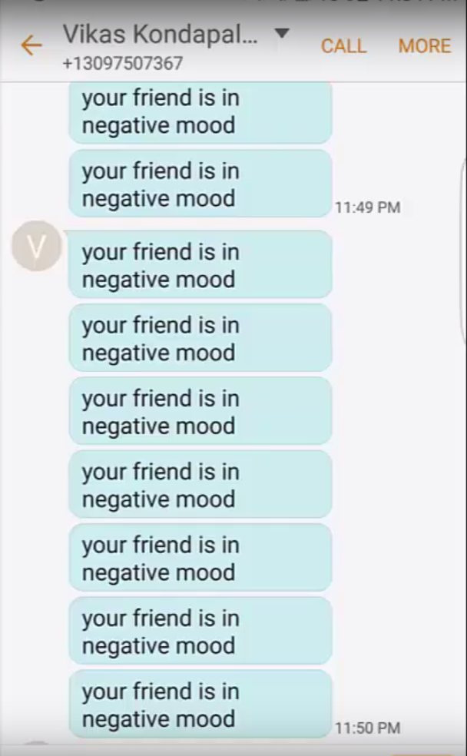

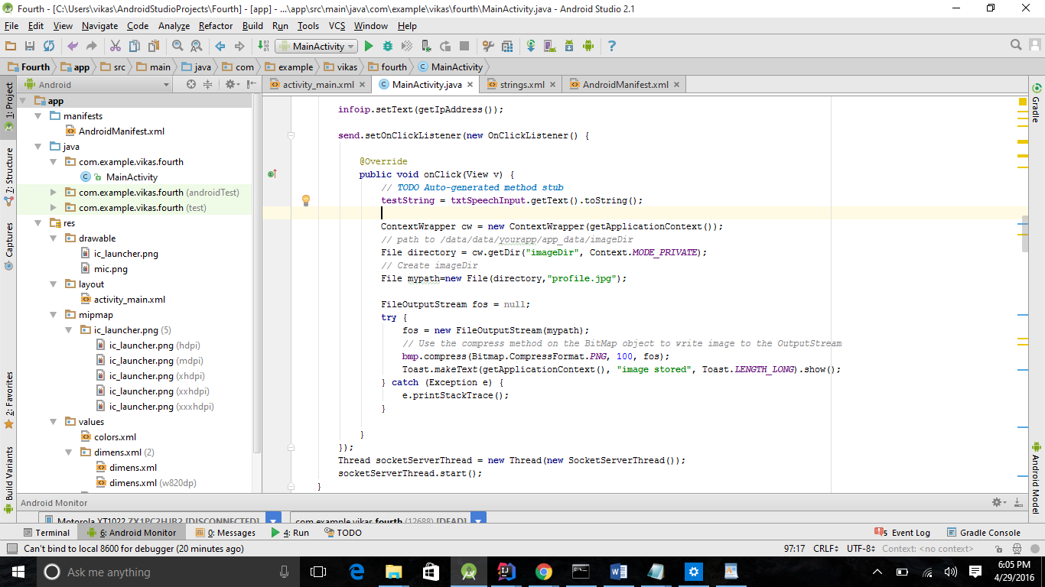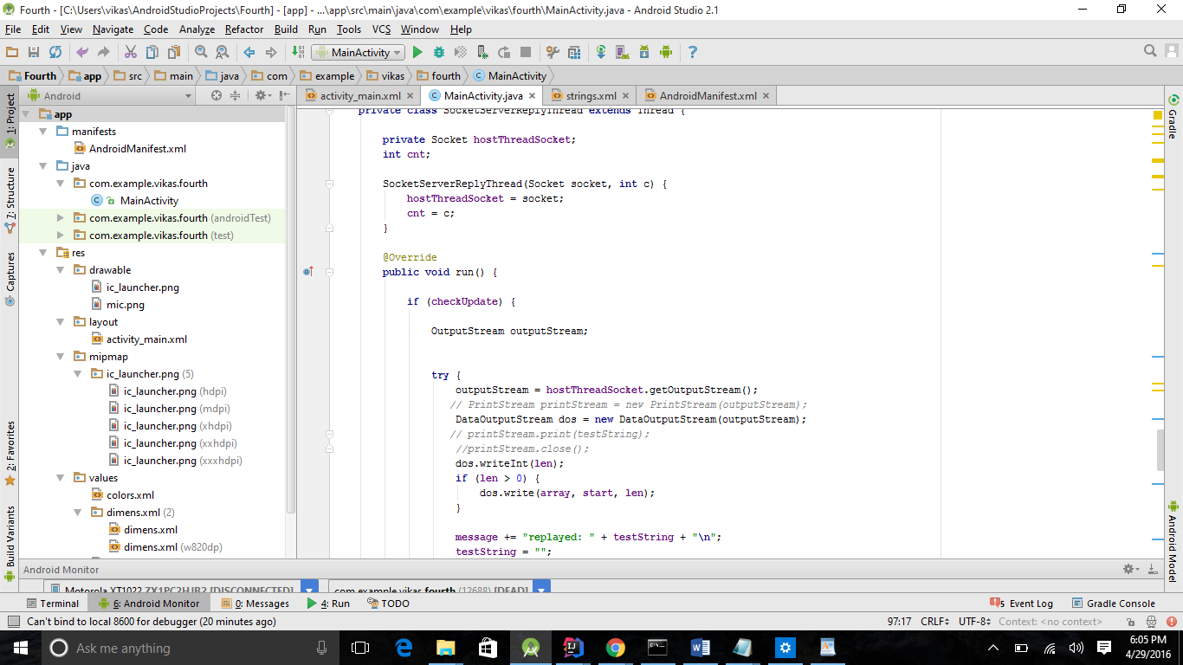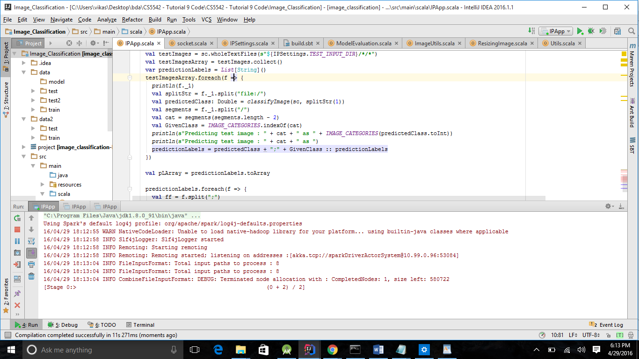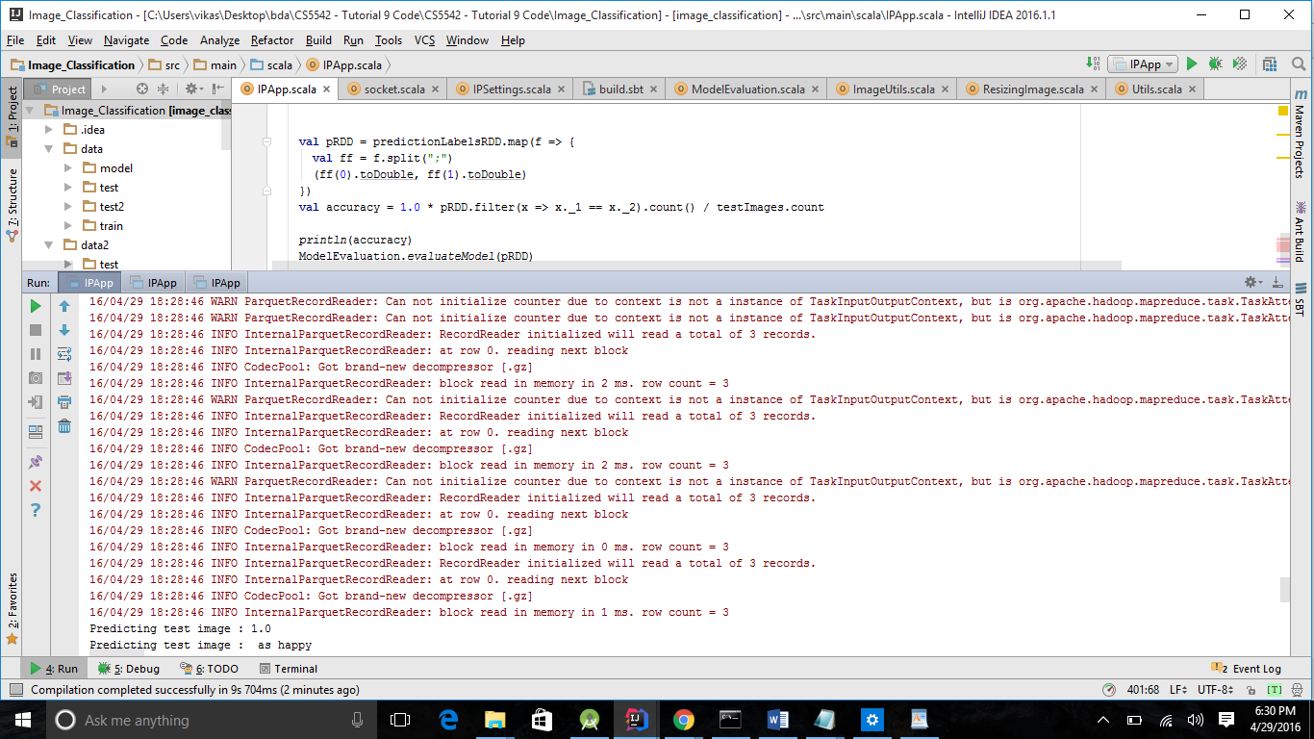

# Bibliography:

1. <http://www.webdesignschoolsguide.com/library/10-things-we-couldnt-do-without-robots.html>
2. <http://www3.imperial.ac.uk/newsandeventspggrp/imperialcollege/newssummary/news_10-6-2014-11-42-22>
3. <http://www.burke.org/media/press/2013/04/burke-medical-research-institute-opens-new/57>
4. <http://www.mayoclinic.org/tests-procedures/robotic-surgery/care-at-mayo-clinic/treatment/prc-20013988>
5. <https://en.wikipedia.org/wiki/Random_forest>
6. <http://www.saedsayad.com/decision_tree.htm>

# Presentation Slides:

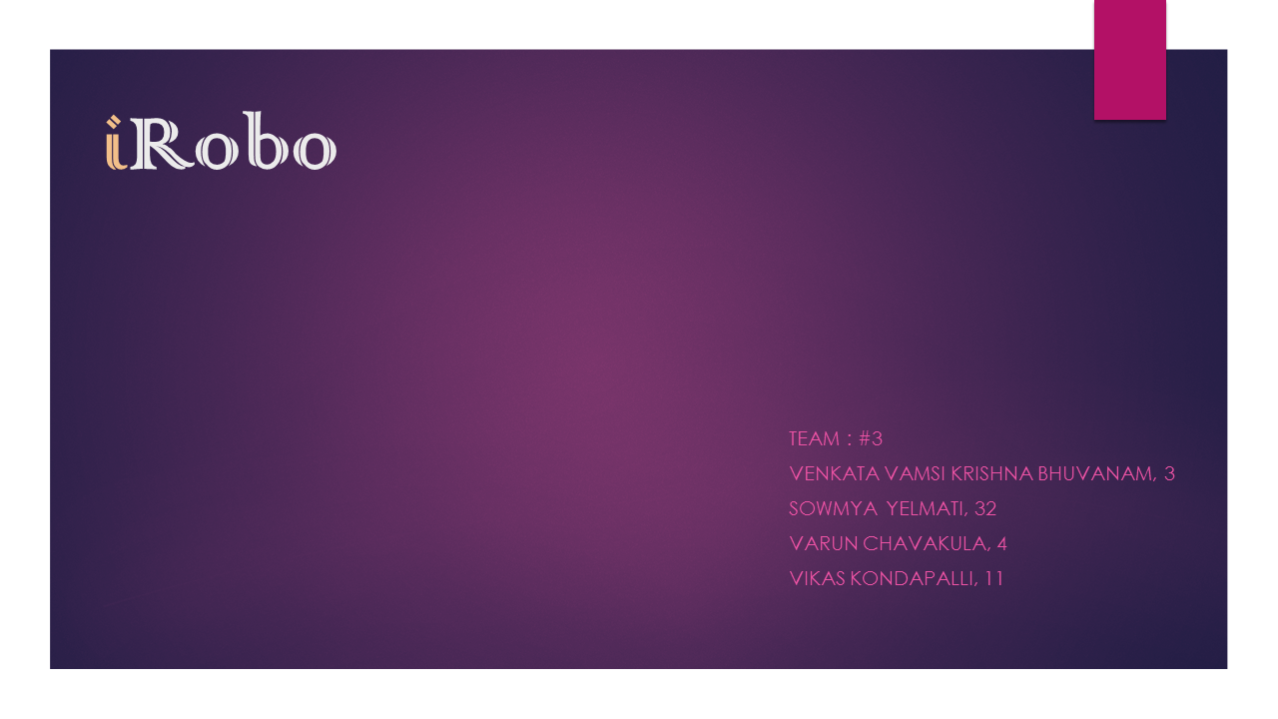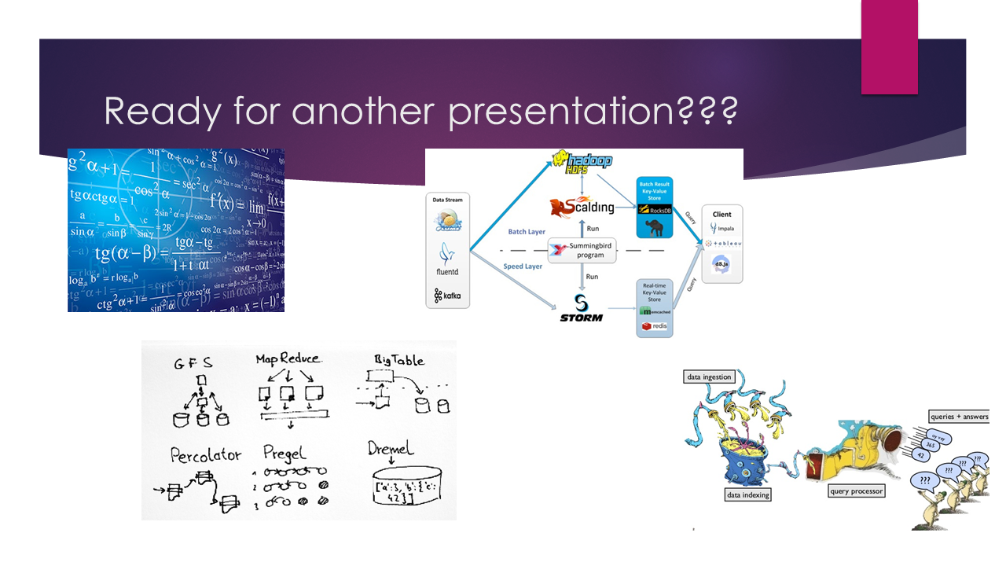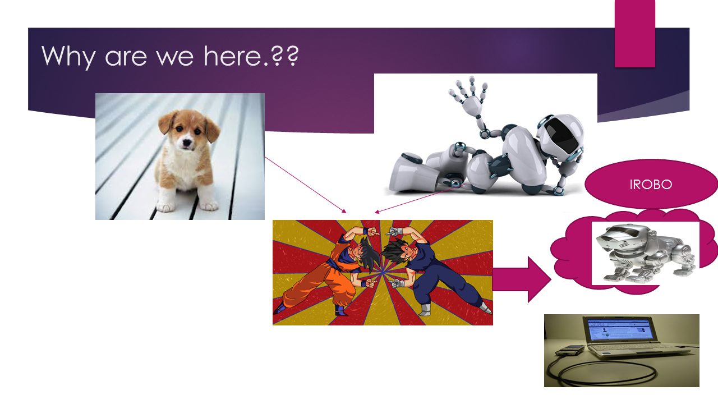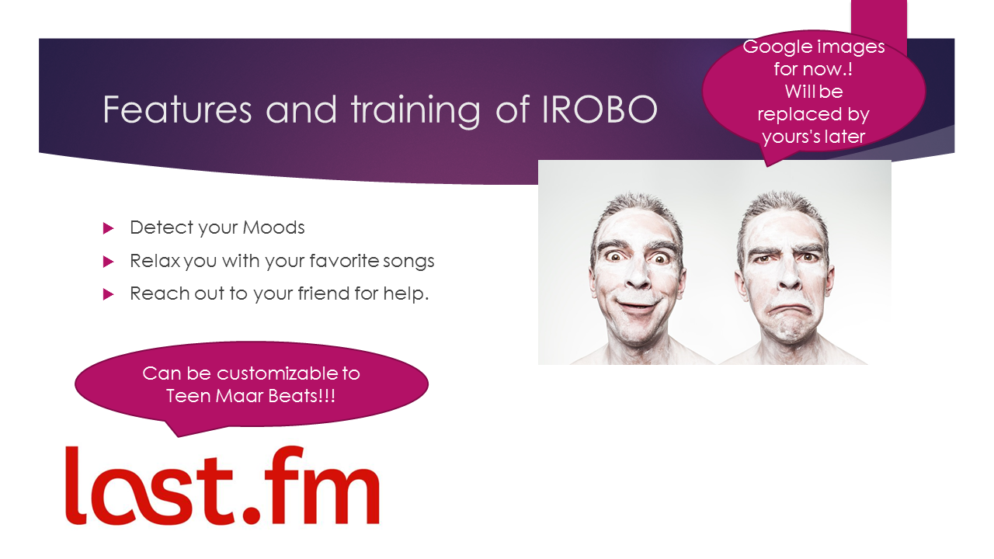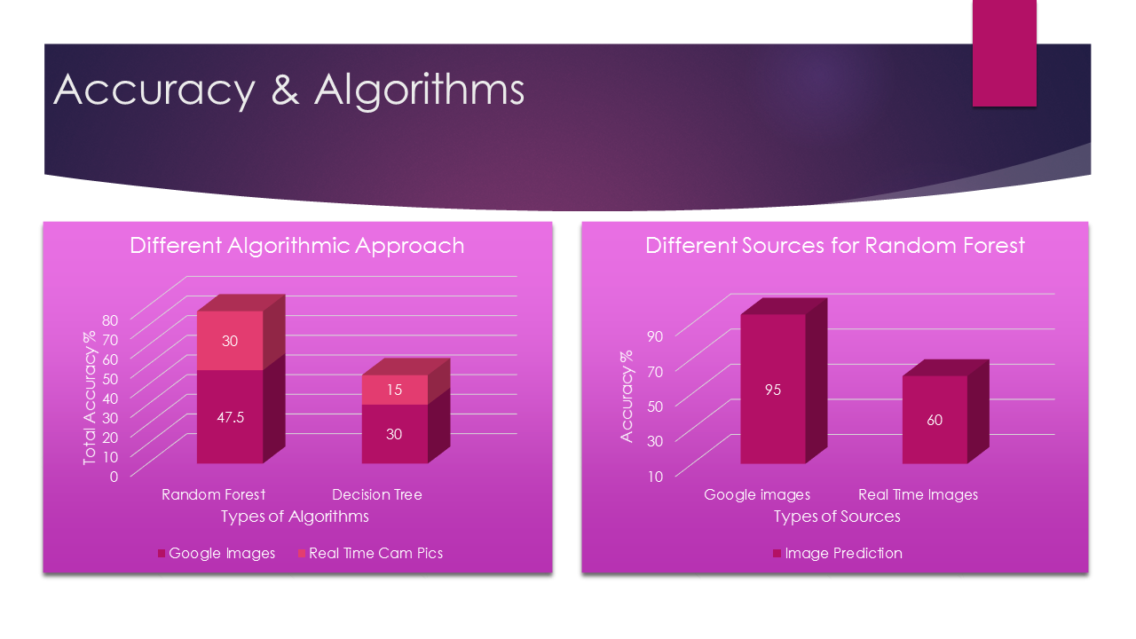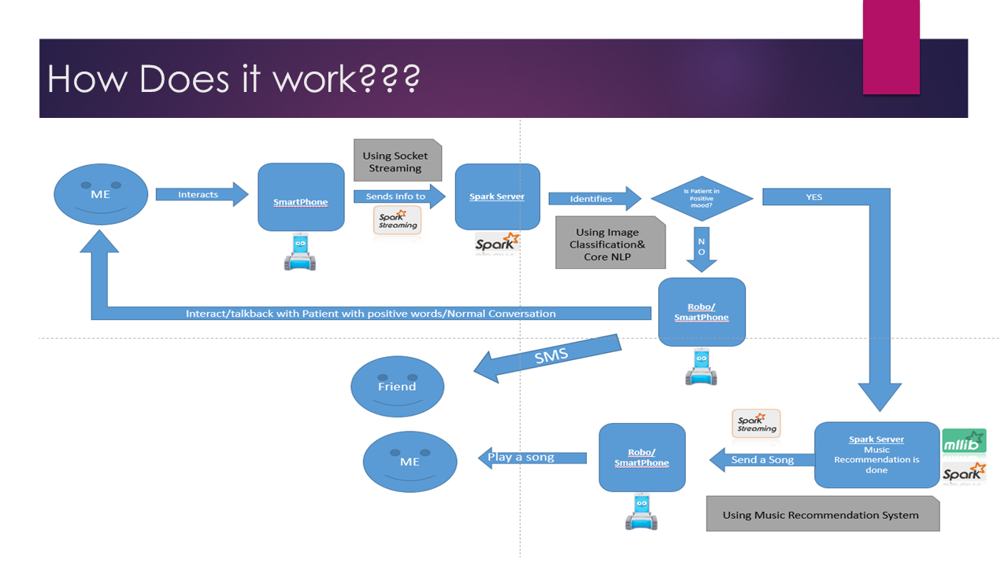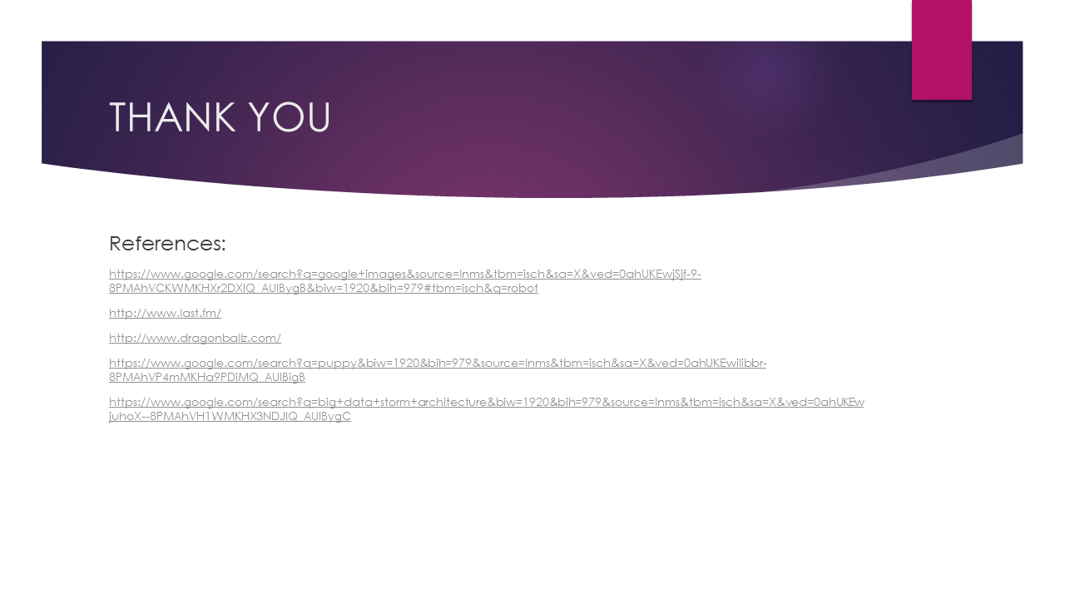

# Github URL:

<https://github.com/SCE-UMKC/BigData-Spring2016-iRobo>

# Youtube URL:

<https://www.youtube.com/watch?v=xzk0oKaLFKg>

# Project Summary Report:

## Introduction:

**Motivation:**

In medical field in any hospital patients feel so lonely after some days and even research proved that constant attention helps healing faster than keeping them lonely. So this robot will interact with patients based on their mood swing. This will even help doctors to keep on monitoring patient under doctor’s radar. Say that patient is happy, it will ask in cheering voice that “ How are you sir, Seems like you are so happy, is it because of any happy memories, or any good news, can you please share with me too…” or if patient is so sad, based on his medical history it will talk saying that “ You seem so sad sir, don’t feel that way, be happy, Can I sing some songs, can I dance <to make it laugh>, can I tell joke”

**Objectives:**

This will help patient think in good mood and won’t make them feel lonely. Also in hospital room it will keep on monitoring the monitors and will keep on updating doctors on the status of the patient by using patient id and name using messaging/email. Robot might even suggest calling particular people based on mood swings. This robot might even translate from one language to another where patient will talk in one language and it talks back to doctor in another language.

## Solutions:

### Architecture:

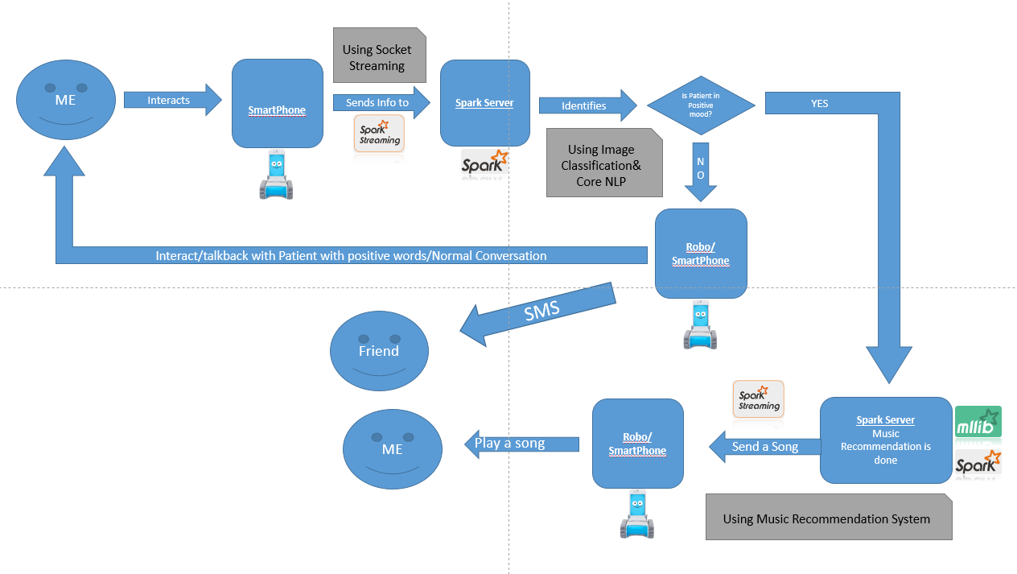

### Algorithms:

We have used Decision tree at first but since we are getting very less accuracy, we have moved to Random Forest Approach where we are getting incredible accuracy with huge change when compared to Decision Tree Algorithm.

**Decision Tree:**

|  |
| --- |
| Decision tree builds classification or regression models in the form of a tree structure. It breaks down a dataset into smaller and smaller subsets while at the same time an associated decision tree is incrementally developed. The final result is a tree with **decision nodes** and **leaf nodes**. A decision node (e.g., Outlook) has two or more branches (e.g., Sunny, Overcast and Rainy). Leaf node (e.g., Play) represents a classification or decision. The topmost decision node in a tree which corresponds to the best predictor called **root node**. Decision trees can handle both categorical and numerical data. |
|  |
| http://www.saedsayad.com/images/Decision_Tree_1.png |
|  |
| **Algorithm** |
| The core algorithm for building decision trees called **ID3** by J. R. Quinlan which employs a top-down, greedy search through the space of possible branches with no backtracking. ID3 uses *Entropy* and *Information Gain* to construct a decision tree. |
|  |
| **Entropy** |
| A decision tree is built top-down from a root node and involves partitioning the data into subsets that contain instances with similar values (homogenous). ID3 algorithm uses entropy to calculate the homogeneity of a sample. If the sample is completely homogeneous the entropy is zero and if the sample is an equally divided it has entropy of one. |
|  |
| http://www.saedsayad.com/images/Entropy.png |

**Example Figure:** 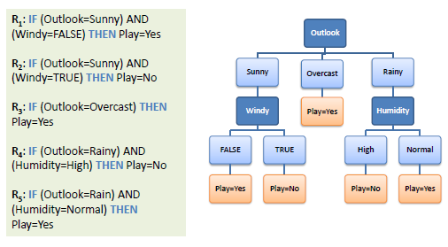

**Random Forest:**

Random forests is a notion of the general technique of random decision forests that are an [ensemble learning](https://en.wikipedia.org/wiki/Ensemble_learning) method for [classification](https://en.wikipedia.org/wiki/Statistical_classification), [regression](https://en.wikipedia.org/wiki/Regression_analysis) and other tasks, that operate by constructing a multitude of [decision trees](https://en.wikipedia.org/wiki/Decision_tree_learning) at training time and outputting the class that is the [mode](https://en.wikipedia.org/wiki/Mode_(statistics)) of the classes (classification) or mean prediction (regression) of the individual trees. Random decision forests correct for decision trees' habit of [overfitting](https://en.wikipedia.org/wiki/Overfitting) to their training set.

### Data:

We have used last.fm data set for audio classification and We have used live image data relay from camera as image classification data and Training set for image classification was given with some Sample Live Camera Pictures.

### Accuracy:

We achieved the following accuracies with both the algorithms.

### Runtime Performance:

Coming to Runtime Performance, we at first got so many glitches because of combining both the recommendation system but later we have figured a way to solve that issue. Now the application can be used as extension with front end as beautiful cartoon picture talking to a patient.

# Project Management Report:

## Project Management Report

First we have divided the project into three main modules. One which is face detection and another is speech detection and analysis and Music Recommendation.

We divided ourselves to two small teams where one team will deal with image classification and another team deals with Music Recommendation and Speech Analysis is done by sharing the work.

First Team consists of Vamsi (Class ID: 3) and Vikas (Class ID: 11).

Second Team consists of Sowmya (Class ID: 32) and Varun (Class ID: 4).

### Members Work Evaluation:

|  |  |
| --- | --- |
| Name | Contribution % |
| Venkata Vamsi Krishna Bhuvanam | 25% |
| Sowmya Yelmati | 25% |
| Varun Chavakula | 25% |
| Vikas Kondapalli | 25% |

## Final Project Evaluation:

1. Discuss how well your project satisfies your original requirement specifications, were you satisfied with your design process?

Ans: This Project satisfied the main objective of the project, where we can improve more in further iterations with user-friendly cartoon face which interacts with patient.

1. How helpful was the agile process?

Ans: Agile Process is definitely a helpful step to start with the project. Particularly like a project we have chosen, working with module wise will definitely help, with agile the defect identification at early stages and modification at early stages are really helpful.

1. How would you do the agile process next time?

Ans: I would like to use agile process where there is a scope of using it for the improvement of software development quality.

1. Did you stick to your project plan schedule?

Ans: We definitely stick to the project plan schedule, which helped us to keep track on the progress of project.

1. What was the real management structure within your group?

Ans: We divided ourselves to two small teams where one team will deal with image classification and another team deals with Music Recommendation and Speech Analysis is done by sharing the work. First Team consists of Vamsi (Class ID: 3) and Vikas (Class ID: 11). Second Team consists of Sowmya (Class ID: 32) and Varun (Class ID: 4).

1. Does it bear any resemblance to structure that you had planned?

Ans: Almost the same.

1. Did you have any problems getting each member to do his/her share of the work?

Ans: No. Every team member is equally contributed towards this project which helped alot while integrating the modules. Even if we got some glitches in between, other team will jump in and solve the issues together and get back to their work.

1. Do you have any suggestion on how this could have been handled better?

Ans: This project was handled well as per knowledge.

1. Discuss what you might have done differently if this were a real world project?

Ans: I definitely would have used the agile methodology for the development but rather splitting the team into two (since we didn’t have expertise earlier before starting the project) I will divide the work based on the expertise of the members which will reduce the defect occurrence and the defect density will be reduced drastically.

1. Any recommendations for next year?

Ans: At the time of increment discussions it is better to discuss or jot down the points or features to cover in next increment and document them so that for next increment the team will have an idea on the further development.